Configuration guide

1. download Unity
2. open the project in Unity
3. if you get a prompt about versions, just convert the project to your version of unity

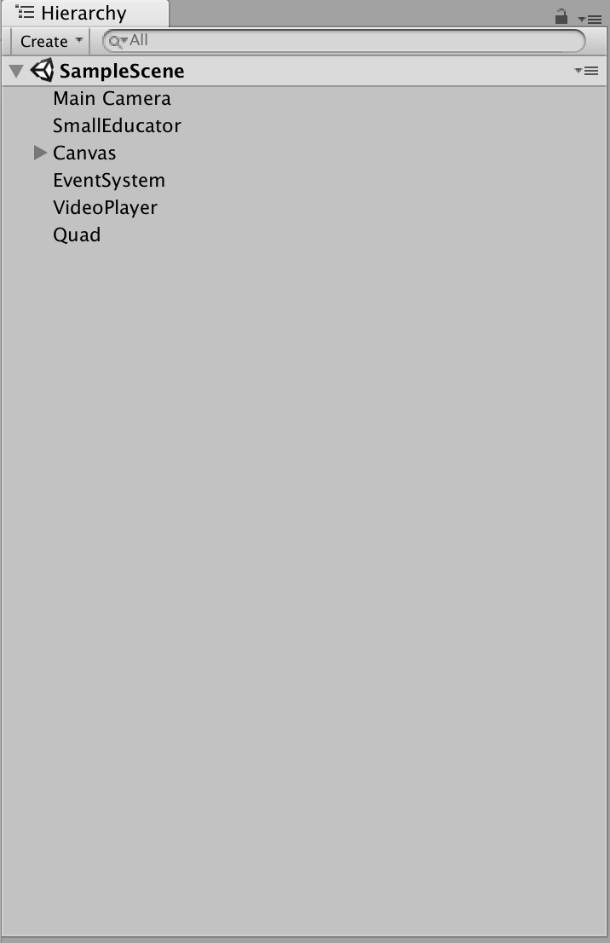

Figure 1: Hierarchy tab

The project will have a Hierarchy tab (see Figure 1: Hierarchy tab) and an inspector tab (right tab on Figure 2: GameObject SmallEducator), these tabs are important to configure the elements of the project. Open the README_.rtf

The first step in this readme is to fix the Hierarchy via added scripts to gameobjects

1. The first gameobject is SmallEducator, this needs to SmallEducator script, as shown by Figure 2. The SmallEducator script is in the root of the Source folder. It can be dragged on the SmallEducator gameobject in the Hierarchy. If done correctly, the attributes of script are shown in the inspector tab if the SmallEducator gameobject is selected in the Hierarchy.
2. The TextTyper script is located in the Source/GUI folder and must be added to both "TextMeshPro Text gameobjects".
3. The TextTyper script is located in the Source/GUI folder and must be added to both "TextMeshPro Text gameobjects".Figure 3 another way to add a script to a gameobject via the inspector. First press the “Add Component”-button, then search for the script and select the script to add from the list.
4. The MultipleChoiceQuestionnair script is also located in the Source/GUI folder. Add this script to the MultipleChoiceQuestionnair gameobject.
5. TestTextOne needs the TextInit script. The location of the TestTextOne gameobject is Assets/Source/, see Figure 4: TestTextInfo

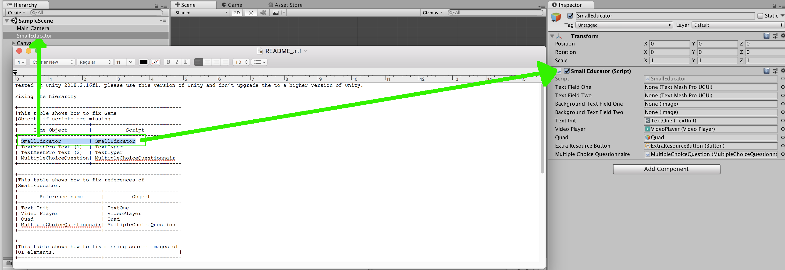

Figure 2: GameObject SmallEducator

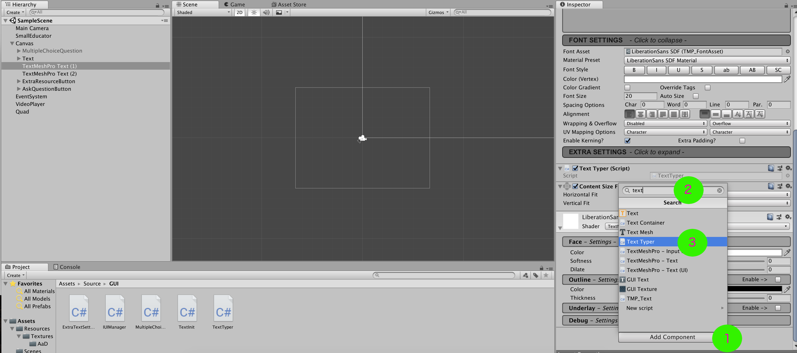

Figure 3: Add script via inspector

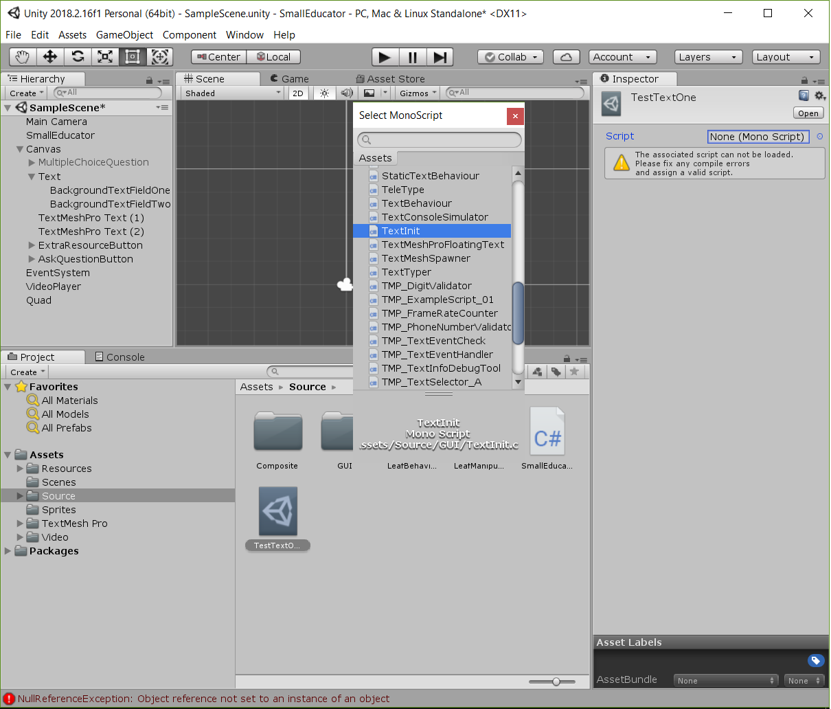

Figure : TestTextInfo

Fix the reference from the SmallEducator script

1. Select the SmallEducator in the Hierarchy tab. The inspector should be the same as shown on Figure 5: Attributes of SmallEducator gameobject, if steps 2, 3 and 4 will fix this.
2. To add the TextInit, press the circle next to the box of the attribute named Text Init, as shown by Figure 6: Green arrow
3. this will prompt a new box where you can select the TextInit from the Assets list, as shown by Figure 7: SmallEducatorInspector TextiInit. So, make sure the correct tab is selected.
4. Repeat steps 2 and 3 for the other attributes of SmallEducator. Figures 7 up to 9 shows the prompts for the other attributes. The other attributes are selected form the scene. So, make sure the Scene tab is active when selecting these attributes.

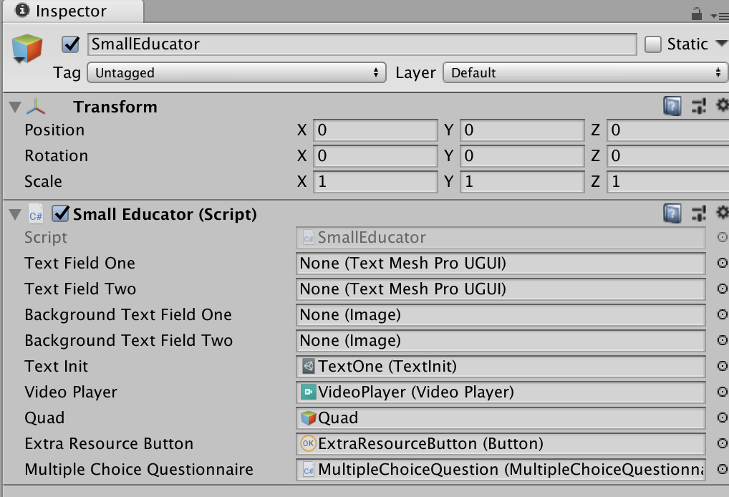

Figure 5: Attributes of SmallEducator gameobject

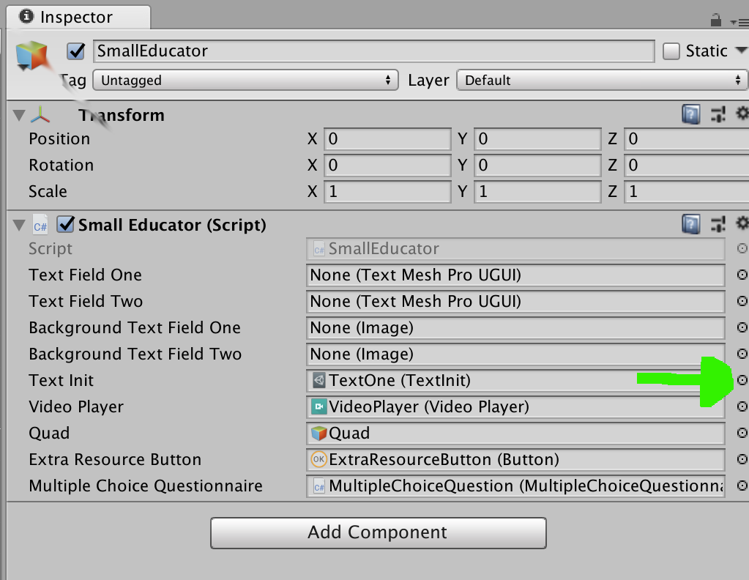

Figure 6: Green arrow

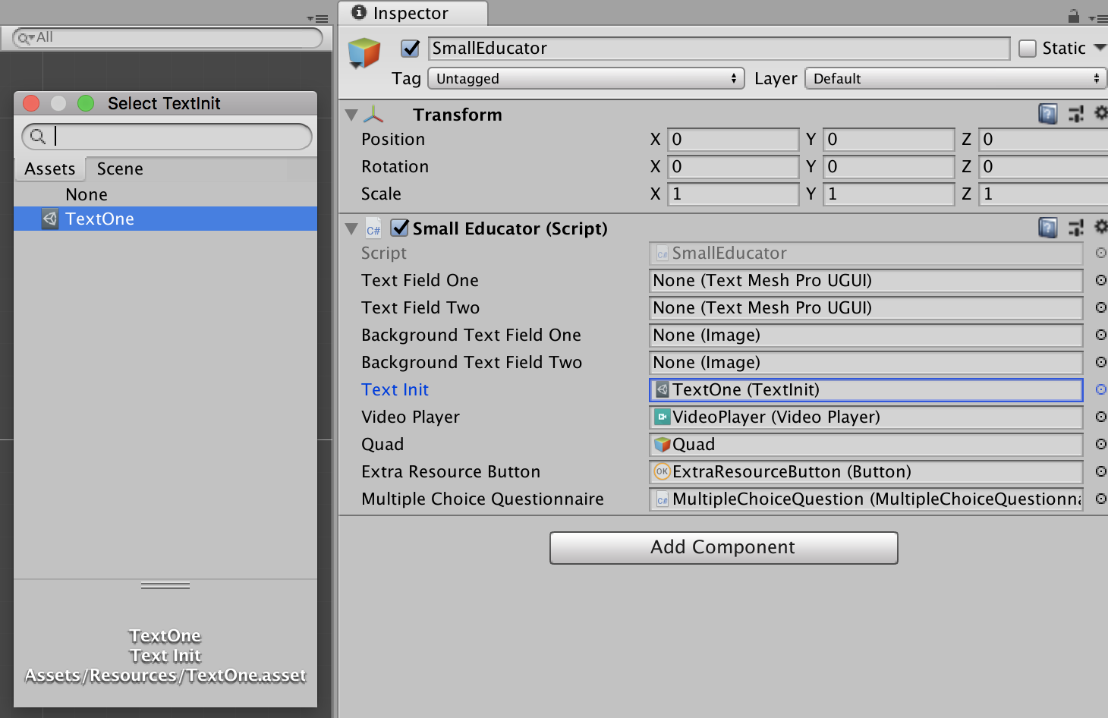

Figure 7: SmallEducatorInspector TextiInit

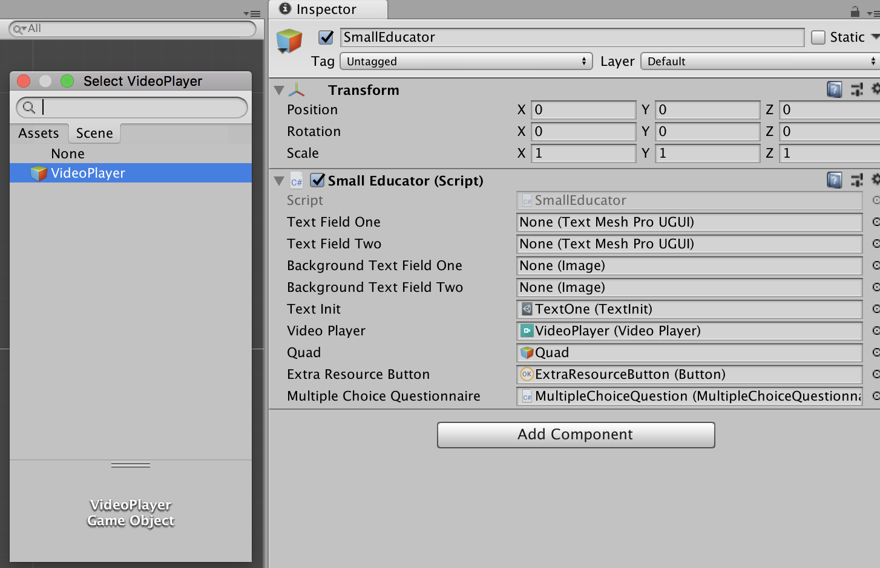

Figure 8: VideoPlayer

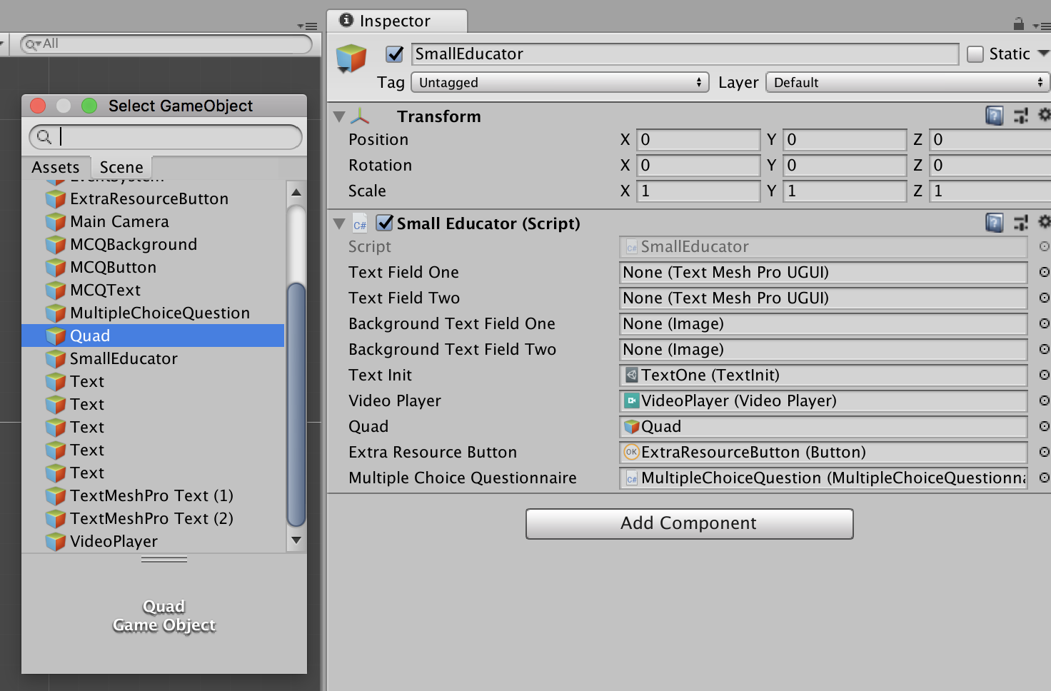

Figure 9: Quad

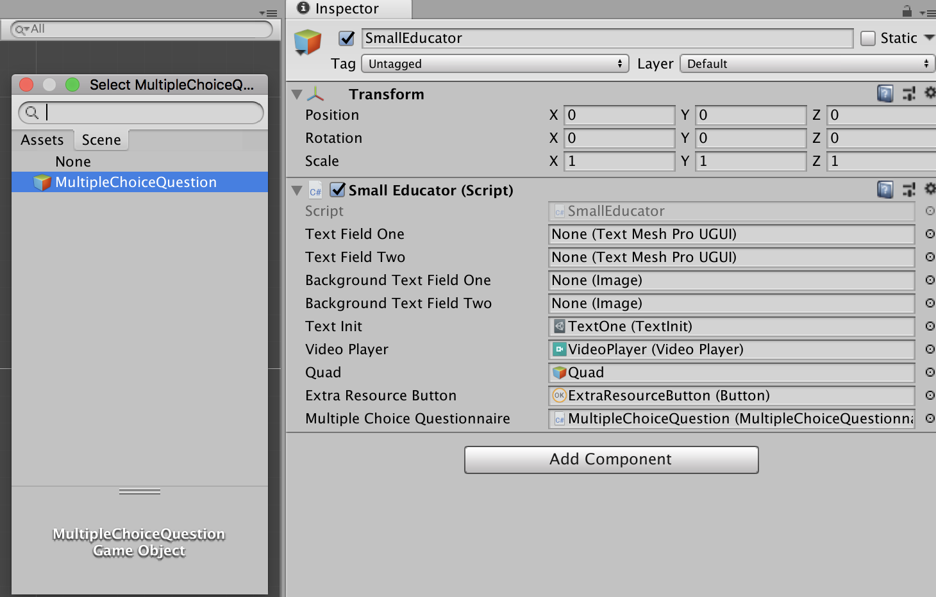

Figure 10: MultipleChoiceQuestion

Now to add images to the AskQuestionButton and ExtraResourcesButton. Figure 11: Location of buttons in hierarchy shows the location of the buttons in the hierarchy.

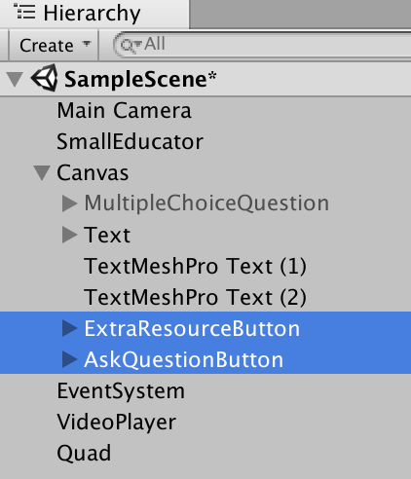

Figure 11: Location of buttons in hierarchy

Press the AskQuestionButton and in the inspector add the QuestionMark images as shown by Figure 12: Questionmark image. Do the same for the ExclamationMarkButton, see Figure 13: Exclamationmark image for help. Both source images are selected from the assets. So, make sure the Assets tab is selected in the “Select Sprite”-window.

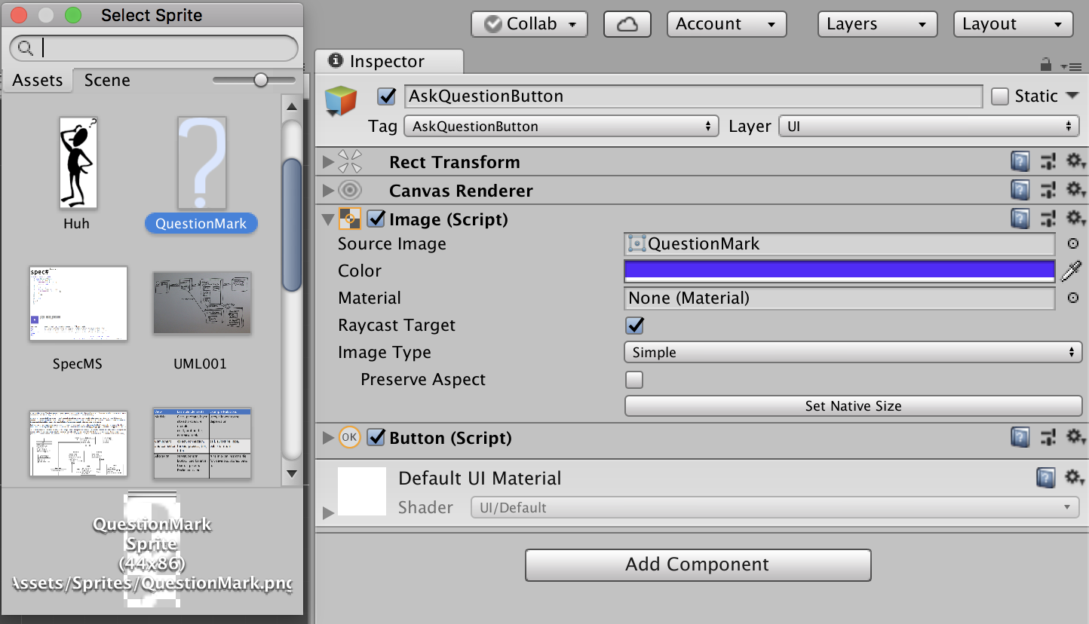

Figure 12: Questionmark image

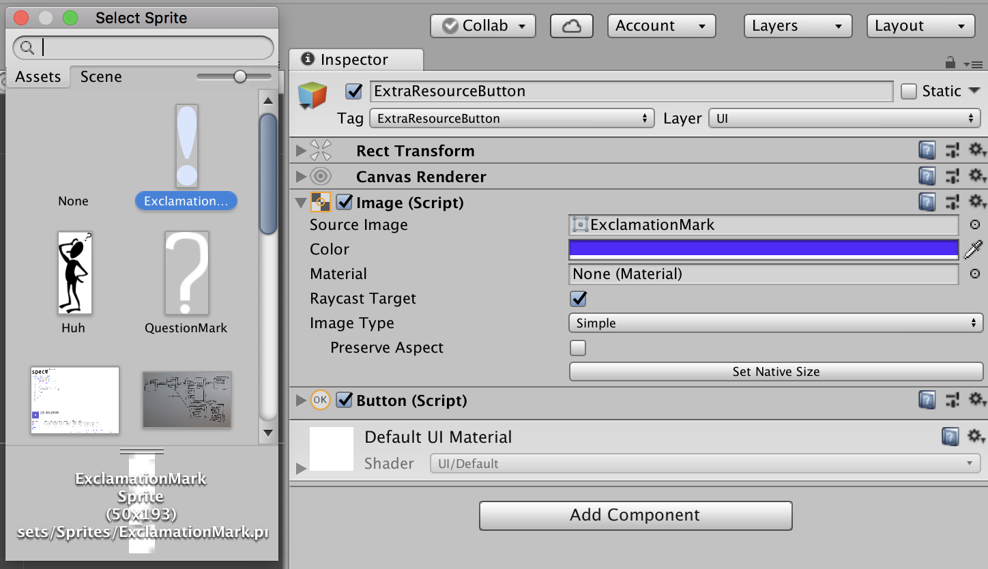

Figure 13: Exclamationmark image

Figure 14 and Figure 15 show the configuration of the OnClick() for both buttons. Make sure the same is done in your project.

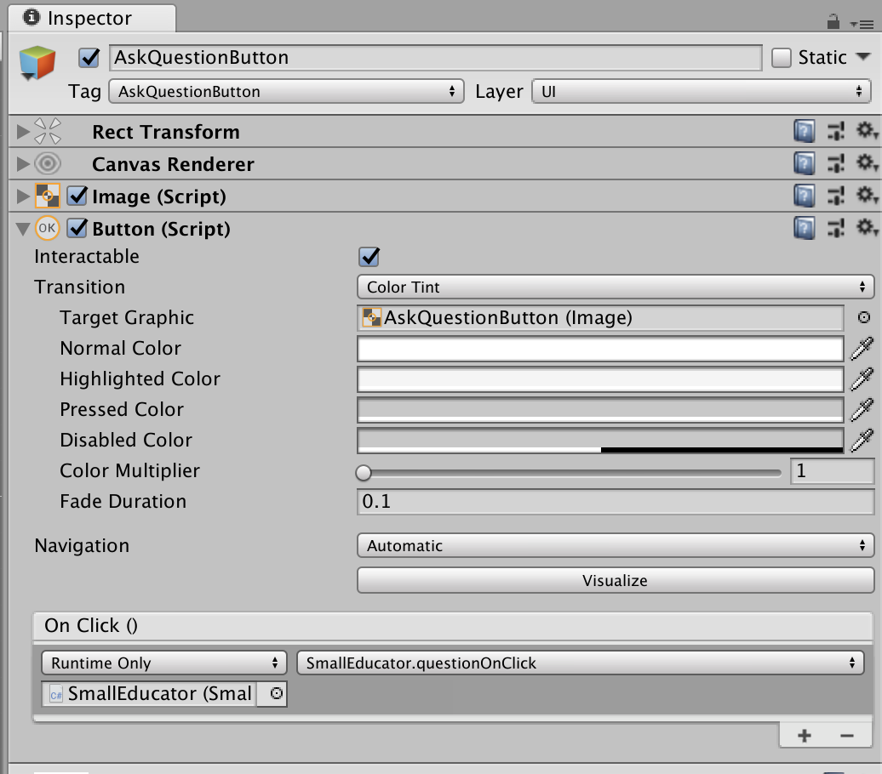

Figure 14: On click settings

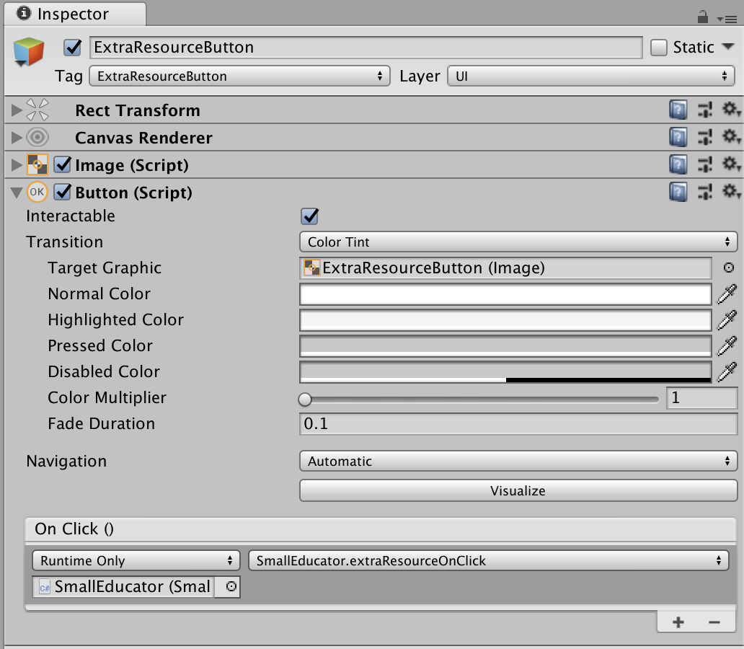

Figure 15: Onclick settings

Figure 16 up till Figure 20 shows the configuration of the MultipleChoiceQuestion. All attributes are selected from the Scene.

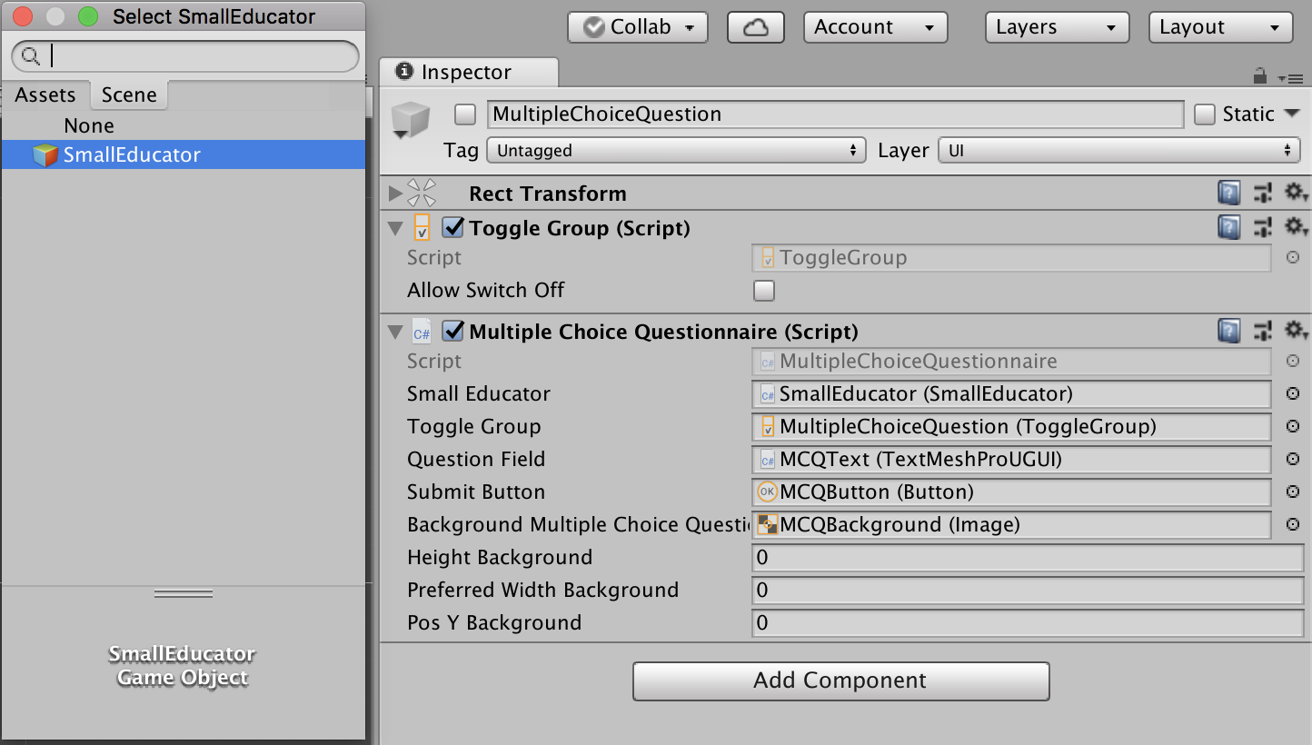

Figure 16: MultipleChoiceQuestion SmallEducator

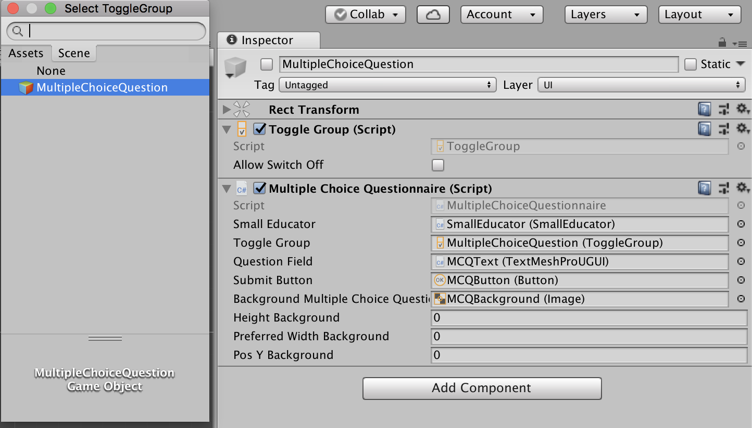

Figure 17: MultipleChoiceQuestion MultipleChoiceQuestion

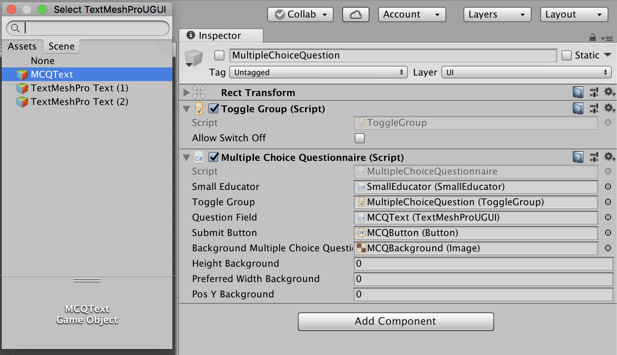

Figure 18 MultipleChoiceQuestion MCQText

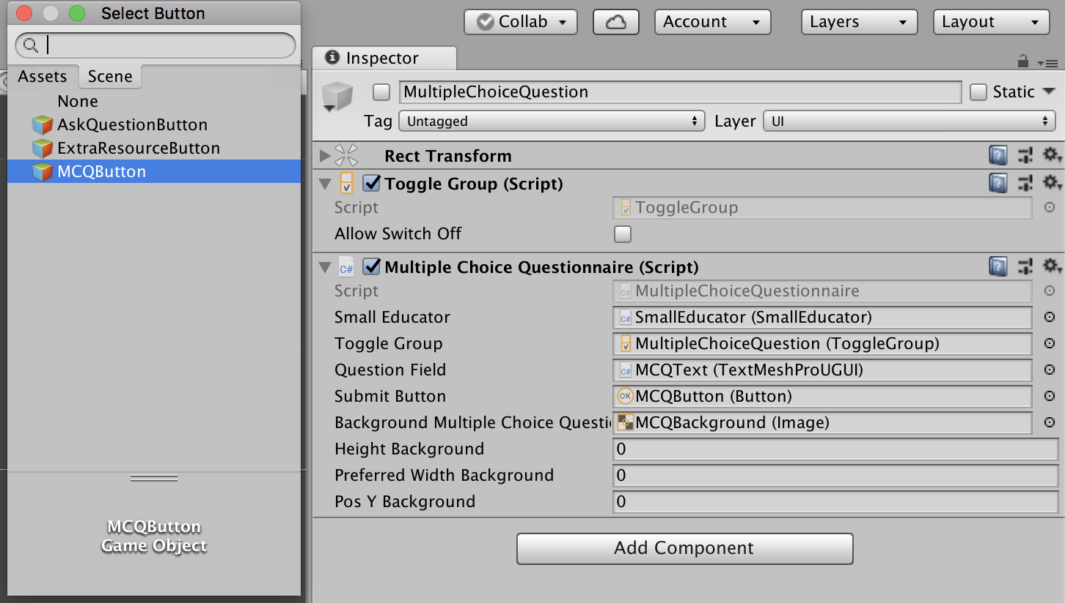

Figure 19 MultipleChoiceQuestion MCQButton

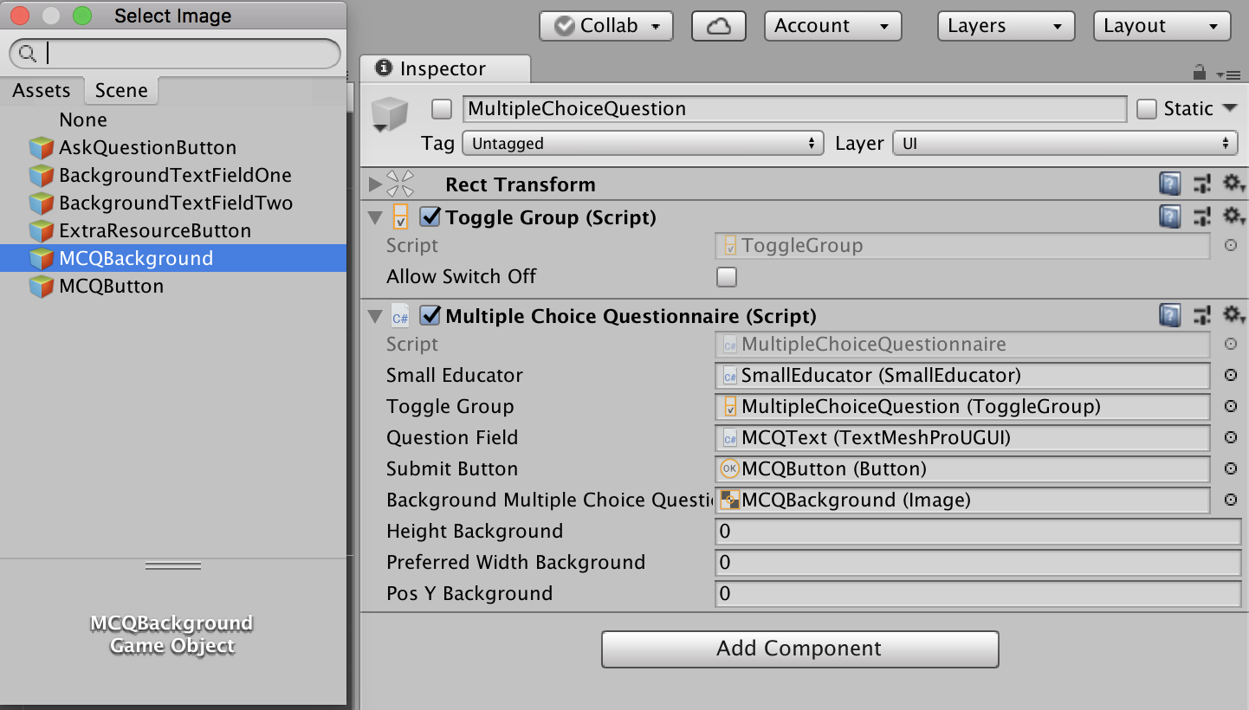

Figure 20: MultipleChoiceQuestion MCQBackground

Last step is to add the background images for the Text fields. Figure 21 shows how to. Both backgrounds are in the assets listing.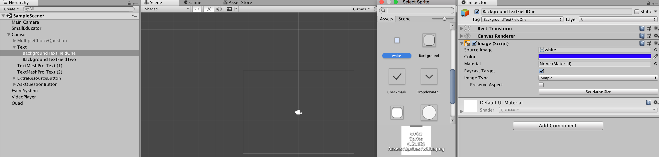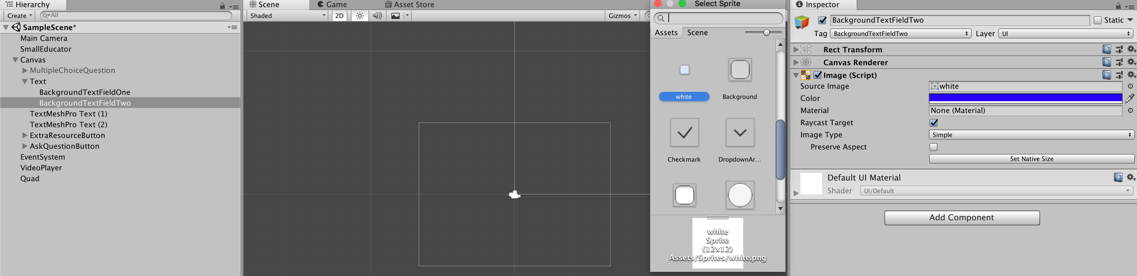

Figure 21: Background images